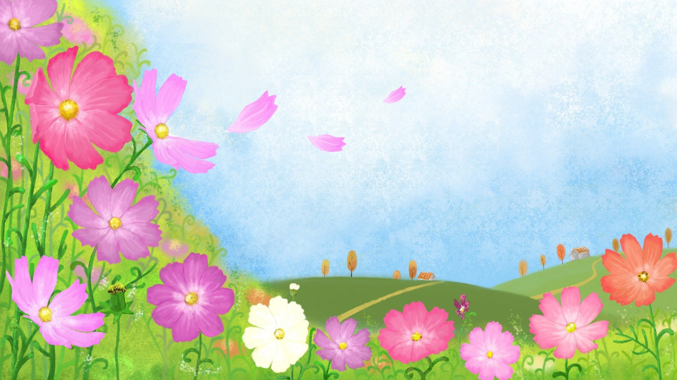

Welcome Spring

Group Connections

Thursday,

April 19th

National High Five Day 11am-12pm

Friday,

April 27th

Spring

10am-11am